LED MOVING HEAD

USER MANUAL

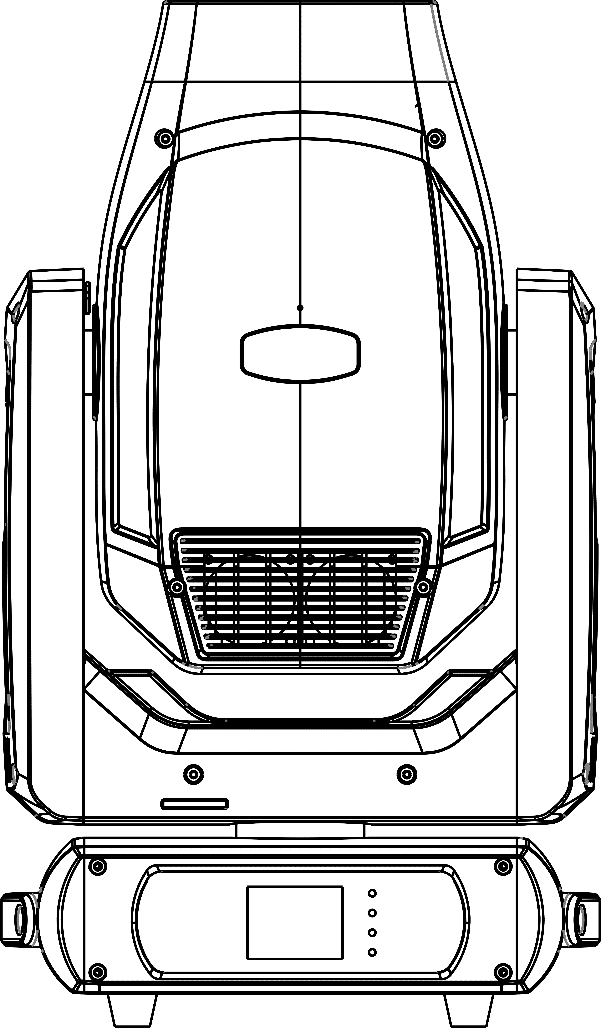

Please read and keep this manual carefully for further use!

Thank you for buying our professional Beam moving head.
This user manual includes important information for installation and operation, so please read this user manual carefully before installation and operation, and keep this user manual well for further use.
In order to install , operate, and maintain the lighting safety and correctly. We suggest that the installation and operation should be done by the verified technician and follow the instruction strictly.
Spare part includes:
Name | QTY | Unit
Fixture | 1 | PC
User manual | 1 | PC
Power cable | 1 | PC
Bracket | 2 | PCS
DMX signal cable | 1 | PC
Safety rope | 1 | PC

Please check carefully that there is no damage caused by transportation. Should there be any, consult your local dealer.
Cautions
Before delivery, this device has passed strict inspection, Please follow the user manual strictly for operation, if this fixture is damaged by improper operation and mistake, the fixture will be out of warranty, and manufacture or dealer won’t be responsible for it. In case of any technology change in this manual,we won’t advise in further .



CAUTION!

Keep this device away from rain and moisture!

Unplug mains lead before opening the housing!

Warning!

Silkscreen symbol on light
Damages caused by the disregard of this user manual are not subject to warranty. The dealer will not accept liability for any resulting defects or problems.

Installation
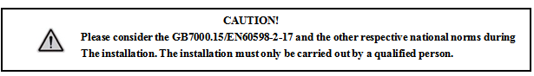

► This fixture is not suitable for direct installation on combustible material surface, please keep the fixture surface at least 0.5m from any combustible material.

► If you use the quick lock cam in hanging up the fixture, please make sure the quick lock fasteners turned in the quick lock holes correctly.
►The applicable temperature for the fixture is between -25°C to 45°C. Do not use the lighting under or above this temperature range.
►The truss for hanging the fixture should be able to hold 10 times weight of this fixture and no deformation after 1 hour hang.
►Please don’t stand under the fixture when install, uninstall, move or repair the fixture.
►Please ensure the light is connected correctly and invite professional technician to check and confirm the electrical data before installation.
►Please invite professional technician to check the fixture and installation each year.
Rigging：

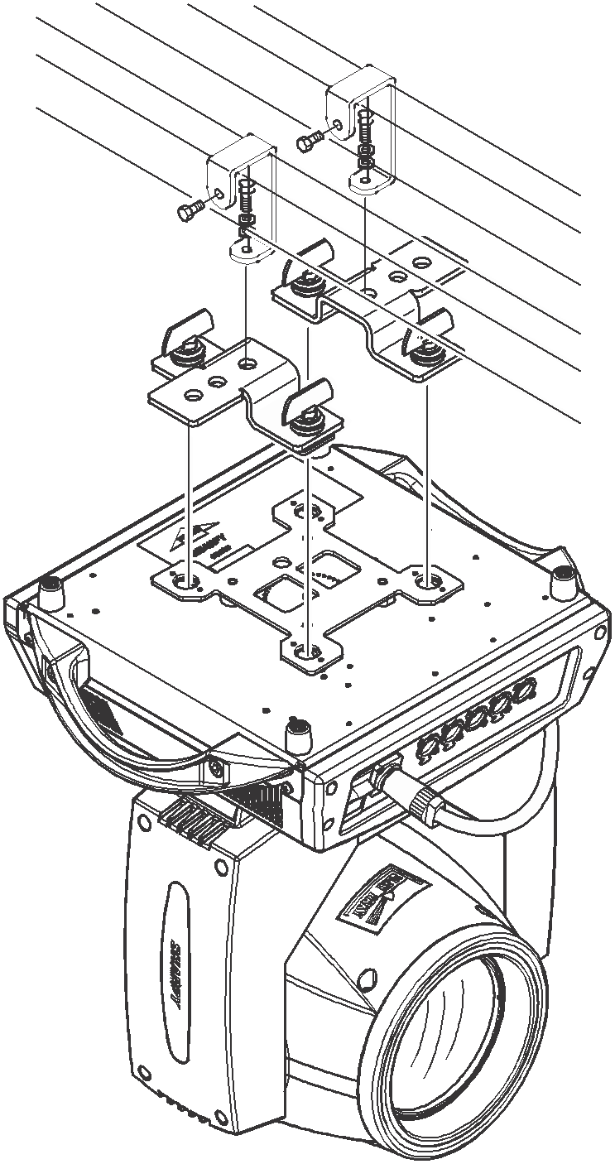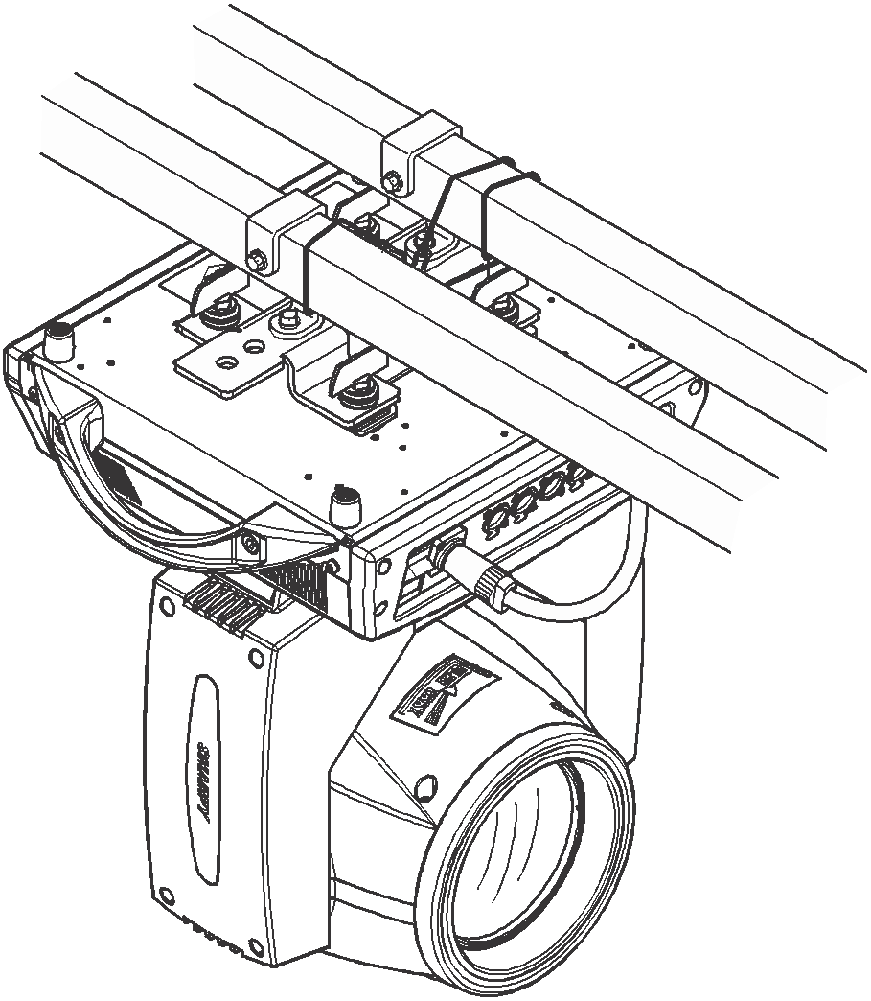

Insert the quick-lock fasteners of the first holder into the respective holes on the bottom of the device.Tighten the quick-lock fasteners fully clockwise.
Fix the clamp on truss or other fixture bracket.
Pull the safety rope through the holes on the bottom of the base and fasten it on the truss or other fixing point.
Note:This step is quite important to ensure that fixture will not drop down for the clamp damage.

Product specification

Voltage：100-240V，50/60HZ；
Power Consumption：500W；
Lamp:400W White LED
DMX Channel: 24CH
Operation mode: master-slave/DMX/Auto/RDM
Electronic strobe: 25Hz
Dimming: 0-100% linear dimming
Fixed gobo: 11 gobos+open
Rotation gobo: 8 gobos+open
Color: 9 colors+open+CTO+CTB
Prism 1: 8-facet
Prism 2: 3-facet
Pan: 540°
Tilt: 270°
Frost: Yes
Focus: Yes
Zoom: Yes
CMY: Yes
Display: LED LCD touch screen

Display and operation

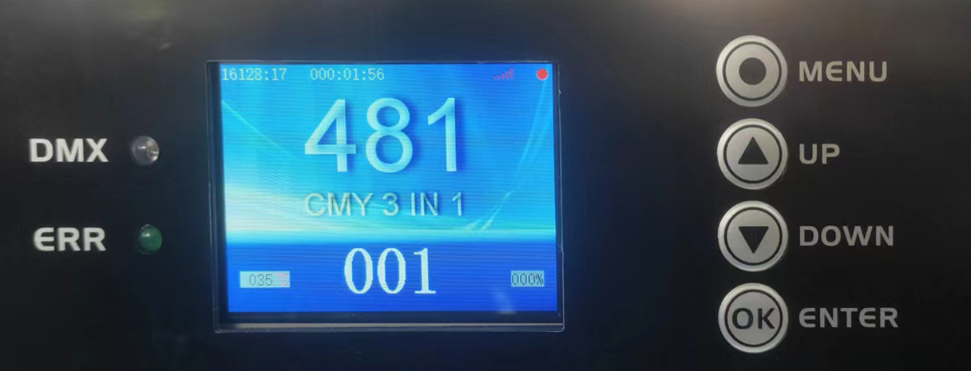

Panel:

DMX | DMX signal indicator
AUDIO | Indicator light when voice activation is triggered
Up | menu up selection
Down | menu down selection
Left | Menu select left/back
Right | Menu select right
ENTER | confirmation button
Time on the left in the upper right corner of the screen | Total system usage time (display can be turned off in standard settings)
Time at the top right corner of the screen | The total time of this power-on (the display can be turned off in the standard setting)
Dot in the upper right corner of the screen | Green: OK, no errors
Dot in the upper right corner of the screen | Red: There is an error (click "Information Menu/Error Information/View" to view the error

System Menu description:

反向 | Reverse | Invert the screen display
退出 | Exit | Exit to the main interface
Language | 语言 | Simplified Chinese or English can be selected
标准设置 | Standard | Address code and some common function settings
高级设置 | Advanced | The main debugging parameter settings at the factory
系统信息 | Info | Information display of errors, software versions, etc.
手动编程 | Program | Manually control the operation, or edit the user program
测试运行 | Perform | Auto-run or voice-activated built-in program, user program
系统复位 | Reset | System reset to initial position

System Menu tree description:

Standard | Default set | Enter? | Restore factory default parameters
Standard | Address | 001-512 | Set light address code
Standard | DMX mode | Mode1  Mode2  Mode3  Mode4 | Select DMX control mode
Standard | Effect mode | No/Yes | effect disc automatically finds the shortest distance to rotate
Standard | Started lamp | Off/on | Choose whether the bulb is "on" or "off" every time you start it
Standard | Switch lamp | Off/on | Turn on the light bulb manually
Standard | No signal | Clear  Hold | Keep DMX value or clear DMX channel value when there is no DMX signal
Standard | UI Color | Green  Blue  Golden  Gray | Choose an on-screen menu color
Standard | Show time | No/Yes | Show runtime timer on main screen
Standard | Brightness | 000-255 | Adjust screen brightness
Standard | Screensaver | Off/on | Turn off the screen when there is no touch and key operation
Standard | XY encoder | No/Yes | Cancel or use XY automatic error correction function
Standard | X inversion | No/Yes | Select the X axis to run forward or backward
Standard | Y inversion | No/Yes | Select the Y axis to run forward or backward
Standard | Focus inversion | No/Yes | Select the focus axis to run forward or backward
Standard | Zoom inversion | No/Yes | Choose to run the magnification axis in forward or reverse direction
Advanced | This setting is the main parameter setting of the light, and permission is required
Info | Error List | No error/View | If there is no error or an error, click OK to view the error
Info | System ver | Vxxxxxxx | System version information
Info | Serial NO. | xxxxxxxx | Equipment factory number
Info | SYS timer | 00000.0H | Total system running time (hours)
Info | Run timer | 000:00 | Running time after this power-on (hours)
Info | Lamp timer | 00000.0H | Total light bulb lighting time (hours)）
Info | Equip TEMP | 000 | The temperature of the main parts of the device (requires device support)
Info | Head TEMP | 000 | The temperature of the light head of the device (requires device support)
perform | Run mode | Auto/Sound | Run selected programs automatically or by voice
perform | Run speed | 255 | Set the speed of the automatic running program
perform | Run cross | 255 | Set slides to run automatically or with voice control (requires device support)
perform | Built-in 1 | Off/on | Device Built-in Test Procedures 1
perform | Built-in 2 | Off/on | Device Built-in Test Procedures 2
perform | User PRO 1 | Off/on | User-programmed program 1
perform | User PRO 2 | Off/on | User-programmed program 2
perform | User PRO 3 | Off/on | User-programmed program 3
perform | User PRO 4 | Off/on | User-programmed program 4
perform | Circle shape | Off/on | (reserve)
perform | Square shape | Off/on | (reserve)
perform | Shape range | 000 | (reserve)
perform | Sound DB | 000 | Adjust voice control sensitivity
Program
Reset | System reset to initial position

24 DMX channel
24CH | Function | Value | Description
CH1 | Pan | 0-255 | 0-540°
CH2 | Pan fine | 0-255 | 0-2°
CH3 | Tilt | 0-255 | 0-270°
CH4 | Tilt fine | 0-255 | 0-1°
CH5 | Pan/Tilt Speed | 0-255 | Speed fast to slow
CH6 | Dimming | 0-255 | 0-100% dimming
CH7 | Strobe | 0-3 | off
CH7 | Strobe | 4-127 | Strobe from slow to fast
CH7 | Strobe | 128-131 | on
CH7 | Strobe | 132-251 | Random Strobe from slow to fast
CH7 | Strobe | 252-255 | on
CH8 | Color | 0-4 | White
CH8 | Color | 5-9 | Red 1
CH8 | Color | 10-14 | Green 2
CH8 | Color | 15-19 | Blue 3
CH8 | Color | 20-24 | Yellow 4
CH8 | Color | 25-29 | Orange red 5
CH8 | Color | 30-34 | Blue green 6
CH8 | Color | 35-39 | Rose 7
CH8 | Color | 40-44 | Orange 8
CH8 | Color | 45-49 | Light blue purple 9
CH8 | Color | 50-54 | CTO 10
CH8 | Color | 55-59 | CTB11
CH8 | Color | 60-64 | White + Red
CH8 | Color | 65-69 | Red+ Green
CH8 | Color | 70-74 | Green + Blue
CH8 | Color | 75-79 | Blue + Yellow
CH8 | Color | 80-84 | Yellow + Rose
CH8 | Color | 85-89 | Rose + Blue green
CH8 | Color | 90-94 | Blue green+ Rose
CH8 | Color | 95-99 | Rose+ Orange
CH8 | Color | 100-104 | Orange+ Light blue purple
CH8 | Color | 105-109 | Light blue purple+ CTO
CH8 | Color | 110-114 | CTO+CTB
CH8 | Color | 115-119 | CTB+White
CH8 | Color | 120-185 | Forward flow from fast to slow
CH8 | Color | 186-189 | Stop
CH8 | Color | 190-255 | Reverse flow from slow to fast
CH9 | CMY1 | 0-255 | CMY Blue
CH10 | CMY2 | 0-255 | CMY Red
CH11 | CMY3 | 0-255 | CMY Yellow
CH12 | Fixed gobo | 0-5 | White
CH12 | Fixed gobo | 6-11 | Gobo 1
CH12 | Fixed gobo | 12-17 | Gobo 2
CH12 | Fixed gobo | 18-23 | Gobo 3
CH12 | Fixed gobo | 24-29 | Gobo 4
CH12 | Fixed gobo | 30-35 | Gobo 5
CH12 | Fixed gobo | 36-41 | Gobo 6
CH12 | Fixed gobo | 42-47 | Gobo 7
CH12 | Fixed gobo | 48-53 | Gobo 8
CH12 | Fixed gobo | 54-59 | Gobo 9
CH12 | Fixed gobo | 60-65 | Gobo 10
CH12 | Fixed gobo | 66-71 | White 11
CH12 | Fixed gobo | 72-77 | Gobo 1 shake from slow to fast
CH12 | Fixed gobo | 78-83 | Gobo 2 shake from slow to fast
CH12 | Fixed gobo | 84-89 | Gobo 3 shake from slow to fast
CH12 | Fixed gobo | 90-95 | Gobo 4 shake from slow to fast
CH12 | Fixed gobo | 96-101 | Gobo 5 shake from slow to fast
CH12 | Fixed gobo | 102-107 | Gobo 6 shake from slow to fast
CH12 | Fixed gobo | 108-113 | Gobo 7 shake from slow to fast
CH12 | Fixed gobo | 114-119 | Gobo 8 shake from slow to fast
CH12 | Fixed gobo | 120-125 | Gobo 9 shake from slow to fast
CH12 | Fixed gobo | 126-131 | Gobo 10 shake from slow to fast
CH12 | Fixed gobo | 132-136 | Gobo 11 shake from slow to fast
CH12 | Fixed gobo | 137-190 | Reverse flow from fast to slow
CH12 | Fixed gobo | 191-192 | Stop
CH12 | Fixed gobo | 193-255 | Forward flow from slow to fast
CH13 | Glass gobo | 0-6 | White
CH13 | Glass gobo | 7-13 | Gobo 1
CH13 | Glass gobo | 14-20 | Gobo 2
CH13 | Glass gobo | 21-27 | Gobo 3
CH13 | Glass gobo | 28-34 | Gobo 4
CH13 | Glass gobo | 35-41 | Gobo 5
CH13 | Glass gobo | 42-48 | Gobo 6
CH13 | Glass gobo | 49-55 | Gobo 7
CH13 | Glass gobo | 56-62 | Gobo 8
CH13 | Glass gobo | 63-69 | Gobo 1 shake from slow to fast
CH13 | Glass gobo | 70-76 | Gobo 2 shake from slow to fast
CH13 | Glass gobo | 77-83 | Gobo 3 shake from slow to fast
CH13 | Glass gobo | 84-90 | Gobo 4 shake from slow to fast
CH13 | Glass gobo | 91-97 | Gobo 5 shake from slow to fast
CH13 | Glass gobo | 98-104 | Gobo 6 shake from slow to fast
CH13 | Glass gobo | 105-111 | Gobo 7 shake from slow to fast
CH13 | Glass gobo | 112-118 | Gobo 8 shake from slow to fast
CH13 | Glass gobo | 119-184 | Forward flow from fast to slow
CH13 | Glass gobo | 185-255 | Reverse flow from slow to fast
CH14 | Gobo rotation | 0-127 | 0-360°
CH14 | Gobo rotation | 128-190 | Reverse flow from fast to slow
CH14 | Gobo rotation | 191-192 | Stop
CH14 | Gobo rotation | 193-255 | Forward flow from slow to fast
CH15 | Prism 1 | 0-127 | no prism
CH15 | Prism 1 | 128-255 | prism 1
CH16 | Prism 1 rotation | 0-127 | 0-400°
CH16 | Prism 1 rotation | 128-187 | Forward flow from fast to slow
CH16 | Prism 1 rotation | 188-195 | Stop
CH16 | Prism 1 rotation | 196-255 | Reverse flow from slow to fast
CH17 | Prism 2 | 0-127 | no prism
CH17 | Prism 2 | 128-255 | prism 2
CH18 | Prism 2 rotation | 0-127 | 0-400°
CH18 | Prism 2 rotation | 128-187 | Forward flow from fast to slow
CH18 | Prism 2 rotation | 188-195 | Stop
CH18 | Prism 2 rotation | 196-255 | Reverse flow from slow to fast
CH19 | Frost | 0-127 | No effect
CH19 | Frost | 128-255 | Frost
CH20 | Zoom | 0-255 | Small to large
CH21 | Focus | 0-255 | far to near
CH22 | Focus fine | 0-255
CH23 | Auto | 0-49 | No effect
CH23 | Auto | 50-99 | Pan auto
CH23 | Auto | 100-149 | Tilt auto
CH23 | Auto | 150-199 | Pan/Tilt auto
CH23 | Auto | 200-255 | No effect
CH24 | Reset | 0-209 | No effect
CH24 | Reset | 210-215 | Pan/Tilt reset after 6s
CH24 | Reset | 220-235 | Effect motor reset after 6s
CH24 | Reset | 240-255 | All reset after 6s

Gobo wheel Color wheel 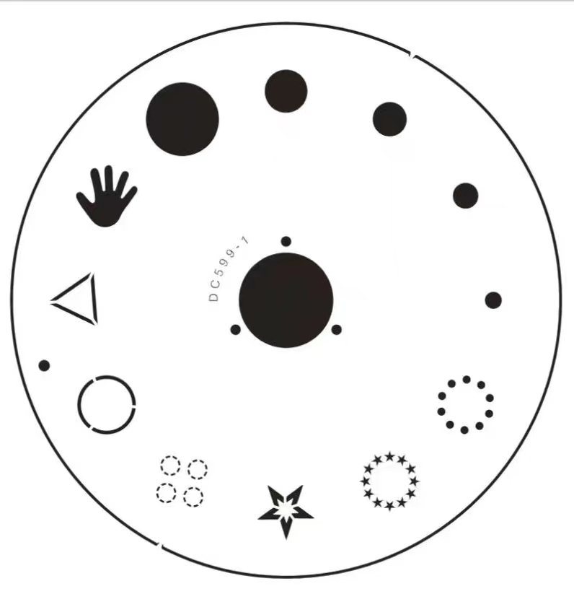 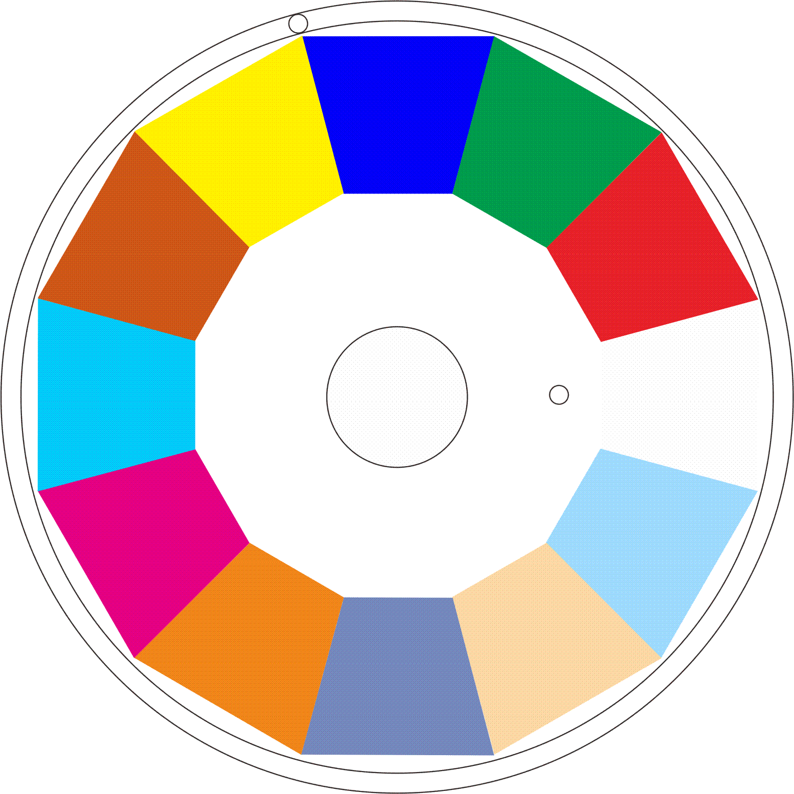
Glass gobo

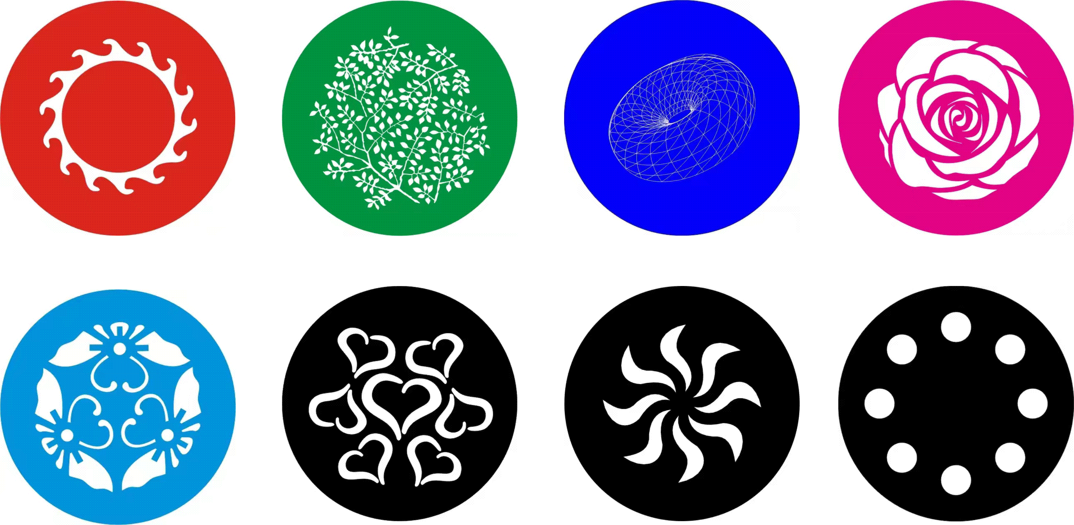

CMY


DMX-512 connection

Connect the provided XLR cable to the male 3-pin XLR output of your controller and the other side to the female 3-pin XLR input of the light.then connect the DMX signal to the first fixture to the 2nd fixture, after all fixtures are connected,

The signal cable should be two - core with screened cable with XLR input and output connectors. Please refer to the diagram below

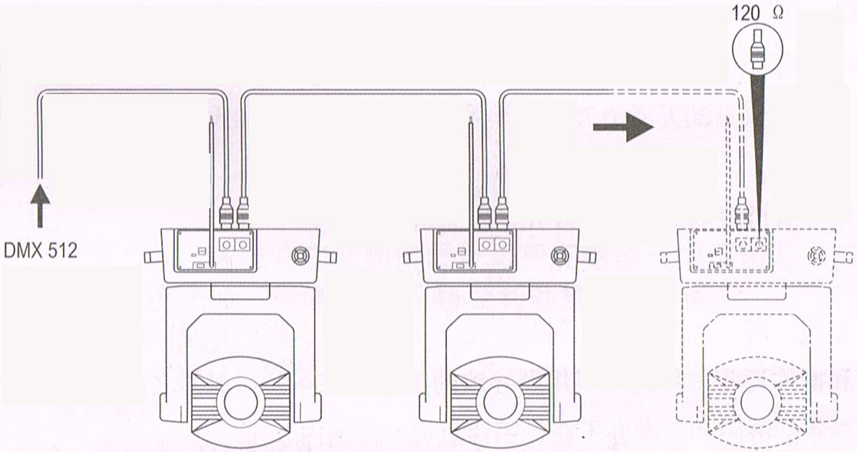

DMX terminator connection
If there are many lines or lights, it is recommended to use a DMX terminator to prevent DMX signal corruption, the DMX terminator is an simple XLR plug with a 120 Ω resistor connected between pins 2 and 3,which is then plugged into the output XLR socket of the last fixture in the chain.
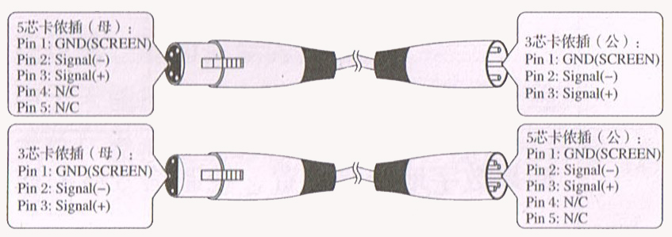
3-Pins connection
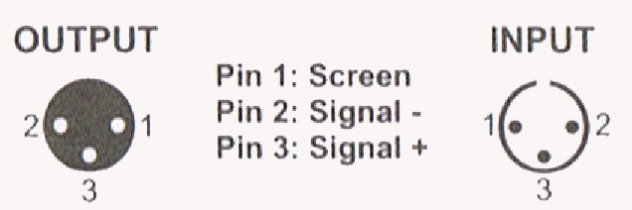
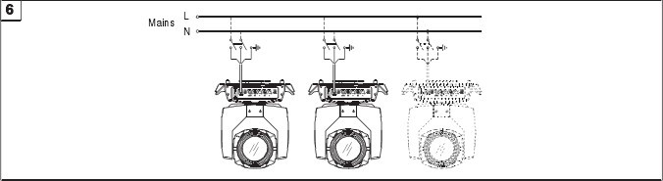
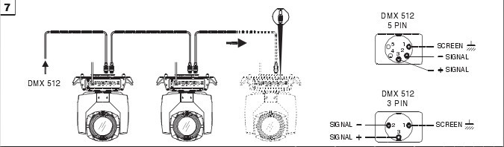

Cleaning and maintenance

Cleaning should be performed every 15-day period, by using a sponge which is dipped with alcohol, rather than wet cloth or other chemical liquid, to clean the mirror.

Cut off power before cleaning and maintenance!
CAUTION

Attention

Do not see directly light source when open the light, and make sure power off before do any installation or maintenance.
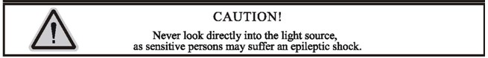
 Wires connection must be done professional person!
CAUTION

Cautions
Before delivery, this device has passed strict inspection, Please follow the user manual strictly for operation, if this fixture is damaged by improper operation and mistake, the fixture will be out of warranty, and manufacture or dealer won’t be responsible for it. In case of any technology change in this manual,we won’t advise in further .

Common issues instruction
Issues | Solve instruction
No power | Check power’s voltage
When power in, output light but the device cannot accept control signal | Check address setting and the control DMX cable connection well or not
The effect have light shadow | Check electronic focus DMX channel value, if it’s suitable distance
Light beam dim | The lamp maybe arrived end of using life, should change new lamp, and also check light source cleaning or not
Note: the maintenance should be done by the verified technician.

Warranty Card
This product is made of high-brightness transistor. We will provide 1 year warranty under the condition that user has operated the light normally and lifetime service. We won't provide warranty if the damage is caused by artificial or force majeure event. Cost of fittings should be charged by user if product need maintenance after 1 year .Please cut this warranty card and shipped it along with the product to our factory when applying for warranty.
Product：
Purchasing date：
Code of invoice：
Warranty date: From To
User’s name： Add：
Company： Tel：

